|  |
| --- |
| Worksheet 4: The Scientific Method |

**Exercise A – Pre-listening Vocabulary**

**Instructions:** Work with a partner or small group to match the words to their definitions. For the words with more than one definition, which definition do you predict will be in a listening about the “The Scientific Method”?

|  |  |  |
| --- | --- | --- |
| causation | hence | repeatable |
| correlation | mislead | reproducibility |
| falsifiable | nonexistence | vice versa |

|  |  |
| --- | --- |
| **Falsifiable** | - **the ability** for a hypothesis or statement to **be proven to be untrue** |
| **reproducibility** | - something that can be **produced or done again in the same way** (noun) |
| **causation** | - the process of one event **causing or producing another event**  - the **relationship between something that happens and the reason for it happening;** the principle that nothing can happen without a cause |
| **Vice versa** | - used to say that **the opposite order** of what you have just said **is also true** |
| **nonexistence** | - ​the fact of **not existing** or **not being real** |
| **correlation** | - **​a connection between two things** in which one thing changes as the other does |
| **Repeatable** | - that **can be** repeated (adjective) |
| **Hence** | For this reason, **we need to be vaccinated**.  Therefore, **we need to be careful when we ski.**  Hence, **we need to study hard**.  So, we need to be careful.  **That** *is* [**why vaccination is important**]. = This is the reason. |
| **Mislead (v.t.)**  **Misled (past tense)** | - ​to give somebody the wrong idea or impression and make them believe something that is not true |

Most definitions from:

Oxford Advanced Learner’s Dictionary online (2020), Oxford University Press: <https://www.oxfordlearnersdictionaries.com/>

**Exercise B – Pre-listening Discussion**

**Instructions**: Discuss the following questions with a partner or small group.

1. Have you ever **misled** someone with something you said? Has anyone ever **misled** you? How did you feel afterwards?
2. Do you think these are **causation** or **correlation**? Why?

e.g. When it’s raining, fewer people ride their bikes to work.

Causation – this can be shown with statistics_________________________________

e.g. People who ride their bikes to work are healthier.

Correlation – this may be true in some cases, but there may be people who drive (or walk) to work who are just as healthy or healthier for other reasons

1. When ice cream sales increase, more people drown in swimming pools.

______________________________________________________________________________

______________________________________________________________________________

______________________________________________________________________________

1. When the weather is warmer, ice cream sales increase.

______________________________________________________________________________

______________________________________________________________________________

______________________________________________________________________________

1. Students who play video games get lower marks.

______________________________________________________________________________

______________________________________________________________________________

______________________________________________________________________________

1. Students who attend every class and work hard get higher participation scores.

______________________________________________________________________________

______________________________________________________________________________

______________________________________________________________________________

1. With your partner, take turns reading the sentences with “vice versa” aloud. The other person should respond by saying *if* the opposite is also true.

e.g. We should go to the gym and then go shopping today, or vice versa.

It might make more sense to go shopping first.

e.g. We should go the gym and then to a bar, not vice versa.

We should not do those in the opposite order!

1. Engineers with degrees from England are not accepted in Canada, and vice versa.

______________________________________________________________________________

1. I need to make dinner and then do some laundry, or vice versa

______________________________________________________________________________

1. I need to get my Canadian driver’s licence before I drive to Banff by myself, not vice versa.

______________________________________________________________________________

**Exercise C – Taking Notes While Listening**

**Instructions:** Below are examples of how notes could be taken on the information in the video. However, only the details are provided. Watch the video and label the main sections. Afterwards, work with a partner to compare your answers.

The Scientific Method

Step 1: **___Observe and ask questions________**

* Helps us make interesting questions to test
* Good questions focus **curiosity**/[passion or interest to know something or the reason for something] into investigation
* e.g. if you see more women smiling: why do women smile more than men?

Step 2: **__search for more information/research________**

* Do others have the same question?
* Search words like: study, research, meta-analysis
* Read a lot
* e.g. research happiness based on gender or smiling in different cultural situations

Step 3: ____guess the reason or **develop/formulate a hypothesis**______

* Hypothesis: idea that can be tested to see if it’s correct
* e.g. observation 🡪 women smile more / people who are happy, smile more
* research 🡪 different kinds of smiles, baby girls smile more
* hypothesis 🡪 women smile more because they are happier

Step 4: ___do/conduct the experiment/test/survey/ test your hypothesis______

* Needs to **be fair** and **consistent**
* e.g. **interview** men and women, count number of smiles, ask about happiness level
* need a large sample size
* but **need to be careful** in case other influences give false results

Step 5: ___**analyze** the data/results_ and conclude_____

* **Look at** the data and change the hypothesis or testing if necessary
* May discover a more interesting question
* Repeat as many times as needed

Step 6: ___Share the results: Be honest, report everything, don’t hide_______

* Be **detailed** about findings AND methods
* **Failed results are also interesting** and useful for others
* **Incorrect hypothesis is fine**! It’s the process that matters

A) Any scientific theory is ___**falsifiable** ________

* Can **never be 100% right**
* Just need as much evidence as possible that it could be correct
* Hard to prove something does not exist
* Easier to show something exists
* Hamsters CAN fly cannot be proven wrong, so it’s not falsifiable (and not scientific)
  + (in case there is some undiscovered species of hamster that can fly)

B) ____Correlation______is not _____Causation_________

* **Correlation**: two things are related but not because of each other
  + e.g. towns with more churches have more bars
  + This doesn’t mean that more churches leads to more bars
  + The population size is likely the cause for both.
  + So there is a correlation between the number of churches and bars
* **Causation**: one thing leads to another (makes it happen)
  + A large population size leads to the need for more bars

C) Avoid **Selective Windowing – choosing or paying attention to only the surface or what superficial or what looks good.**

* Show all the facts in your study
* e.g. a toothpaste company said “80% of dentists” recommended their brand, but those dentists recommended other brands as well
* it’s misleading
* purpose of science: find the truth

**Exercise D – Post-Listening Discussion**

**Instructions:** Using the example from the end of the video, use the scientific method to study Canadian currency: nickels, dimes, quarters, loonies, and toonies.

Hypothesis: bigger coins are worth more money.

Is this correlation or causation? We need to look at all the coins first.

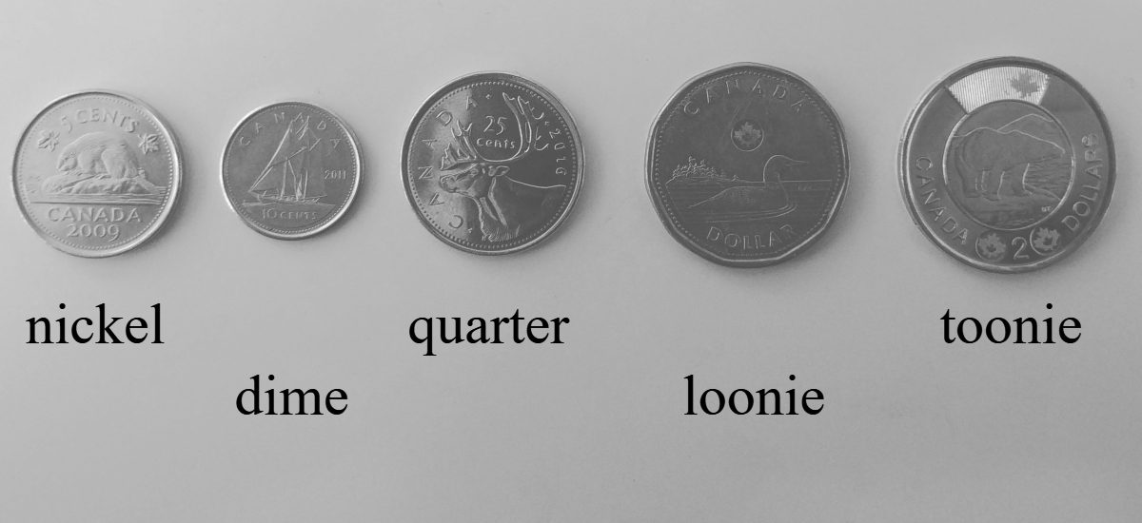

**Discuss with a partner:** Do they all follow the same rule? The larger coin is always worth more than coins smaller than it?

**Exercise E – Maybe and May Be**

In the video, the speaker used “maybe” several times, but he also used “may”.

Look at the examples below from the video.

|  |
| --- |
| **Maybe** they just eat more chocolate and cookies, which makes them both happy and smile a lot. |

|  |
| --- |
| Depending on your findings, you **may** want to change your hypothesis or change the design of your testing. |

**Maybe**

* adverb
* goes before the subject

**May**

* modal verb
* is followed by a **base/infinitive** verb (don’t change its form at all!)
* if the verb is **be**, it’s spelled as **two words** in writing
* in speaking, “maybe” and “**may be**” sound the same

In the following sentences, change “maybe” to “may” and “may” to “maybe”. Write your answer and then read both sentences out loud to your partner.

e.g.Maybe they just eat more chocolate and cookies.

They **may just eat** more chocolate and cookies. (*The word “just” goes between the modal and the base verb.)]*

1. You **may** *want to* **change** your hy**po**thesis. *You **may change** your hypothesis. = You have my permission to change

your hypothesis.

**Maybe you *want to* change your hypothesis. = Maybe you *can* change your hypothesis.**

2. Maybe you have a hypothesis that we can test. Hy**po**the**sis** versus hy**po**the**size**

___You may have a **hypothesis [that** we can test.] _____________________

3. Maybe she need**s** to look at more coins.

_____She may nee**d** to look at more coins. ____________________

4. Maybe it’s because the coin is bigger.

______It may be [_because the coin is bigger__]______________________________

5. That may be the right answer.

_____Maybe that is the right answer. ______________________________________

**Exercise F – Intonation**

Intonation is like the musical notes in speaking. It’s not how loud you are (that’s stress). It’s about how your voice rises or falls. Tone has a musical meaning (about how high or low a note is), but it also means the intended feeling when speaking. Therefore, using intonation can indicate if you are happy, are waiting for an answer, are going to continue speaking, or are being polite.

**Instructions:** Your teacher will play a few parts of the video again to show you examples of intonation.

**From the beginning of the video**

Why are some kids sad?

*(“Wh” questions often have falling intonation. “Do” questions often have rising intonation.)*

What makes the wind blow?

How do birds fly?

*(“How” is considered a “Wh” word for questions. The speaker’s voice does what’s called a “rise-fall” on the word fly. It makes his tone (his feeling) feel lighter, and happier, and engages the audience a bit more. He might be doing this to indicate that it’s the last question in his list.)*

Our world is full of curious phenomena.

*(Regular sentences often have falling intonation at the end. This is especially true when it’s the last sentence in a paragraph or the last sentence of a presentation.*

**Instructions:** Draw arrows above the sentences for the type of intonation that you think the speaker will use. Then your teacher will play the video for you again. What intonation did you here? Was it different from what you predicted? Work with a partner to discuss. Try saying the sentences exactly like the speaker to practice doing the intonation for yourself.

To get a good sample of the population, we invite 300 women and 300 men.

Seems like a good test, right?

But wait, what if the interviewer is a woman, and men tend to smile more at women?

Or vice versa?

**Exercise G – Asking Questions**

**Instructions:** Work with a partner and ask each other the questions below.

Follow the intonation arrows, and answer each other’s questions.

1. Where did you go to high school?

2. Did you have a science lab?

3. What was the most memorable experiment you did in high school?

4. Did you prefer biology, chemistry, or physics? Why?